September 14-16, 2023, Institute of Chemical Technology, Mumbai
Efficient microwave-assisted synthesis of diphenolic acid from bio-renewable levulinic acid and phenol using mesoporous silica-supported modified heteropoly acid
Rohitkumar G. Singh¹, Ganapati D. Yadav²
Department of Chemical Engineering, Institute of Chemical Technology, Nathalal Parekh Marg, Matunga, Mumbai-400019, India^{1,2}
rksingh2480@gmail.com. gd.yadav@ictmumbai.edu.in

Introduction:
Recently, concerns regarding the use of bisphenol A (BPA) in the production of polycarbonate plastics and epoxy resins have escalated due to its link with various health risks, such as hormone disruption and increased cancer susceptibility. To tackle these issues and explore a sustainable substitute, diphenolic acid (DPA) has emerged as a promising bioderived compound similar to BPA[1,2]. This research introduces a solid acid-catalyzed, microwave-assisted synthesis technique, yielding highly favorable P, P'-DPA, superior to O, P'-DPA. The Rb_{0.5}Cs_{2.0}H_{0.5}PW₁₂O₄₀/MCF catalyst ensures a solvent-free and efficient process.

Material and Methods:

2.1. Chemicals & Catalyst:

Phenol, levulinic acid, dodecatungstophosphoric acid (DTP), rubidium chloride, cesium chloride, tetraethyl orthosilicate (TEOS)

2.2. Preparation of bulk and supported catalyst:
Bimetallic salts of DTP prepared through sequential precipitation/ion exchange, and Rb_{0.5}Cs_{2.0}H_{0.5}PW₁₂O₄₀/MCF supported catalyst via sequential incipient wetness.

2.3. Characterization of catalysts:

Catalyst characterization included techniques like BET surface area, TPD-NH₃, XRD, FTIR, SEM-EDX, and TEM for successful formation understanding.
2.4. Experimental setup:

A standard condensation of levulinic acid (LA) and phenol for diphenolic acid (DPA) production was conducted in a sealed glass vessel at 100°C, utilizing a microwave reactor (CEM). The reaction involved 3.7 ml phenol, 1.1 ml LA, and 0.48 g catalyst, with mechanical agitation at 1000 rpm. HPLC with an RI detector monitored LA and DPA concentrations simultaneously at each reaction interval. Scheme 1 represents the reaction process.

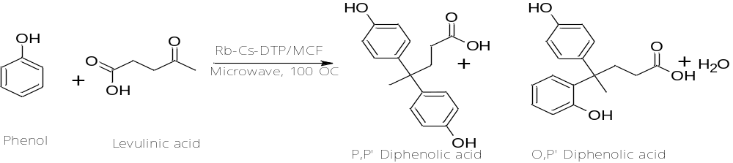

Scheme 1: Condensation of phenol and levulinic acid to form diphenolic acid

Significant Results and Discussion
  - Characterization of catalysts:
The Rb_{0.5}Cs_{2.0}H_{0.5}PW₁₂O₄₀ bimetallic salt exhibited remarkable attributes, boasting the highest surface area and acidity. Utilizing this as a foundation, the supported catalyst Rb_{0.5}Cs_{2.0}H_{0.5}PW₁₂O₄₀/MCF was successfully synthesized and confirmed through extensive analysis. Results from BET surface area analysis, SEM-EDXS, TEM, FTIR, and XRD demonstrated the catalyst's structural integrity and stability, highlighting its promising prospects for various catalytic applications.
  - Optimization of reaction parameters for diphenolic acid (DPA) synthesis:
Various parameters were systematically studied to investigate the reaction rate, optimizing agitation speed (1000 rpm), catalyst loading (0.1 g/mL), mole ratio (1:4), and temperature (100°C) under 100-watt microwave irradiation. Remarkably, 86.5% levulinic acid conversion was achieved in 4 h, with over 80% selectivity for P, P'-DPA. Rb_{0.5}Cs_{2.0}H_{0.5}PW₁₂O₄₀/MCF catalyst showed excellent reusability up to 4 cycles with minimal loss in activity and selectivity.
  - Kinetic modeling:
The analysis of kinetic data strongly suggests that the reaction operates via the Langmuir-Hinshelwood-Hougen-Watson (LHHW) mechanism. By plotting the rate constants obtained from kinetic experiments at various temperatures, an Arrhenius plot was generated, determining the apparent activation energy as 10.17 kcal/mol.

Figure 1: Second order kinetic plot and Arrhenius plot

Conclusions:
A microwave-assisted, solvent-free diphenolic acid (DPA) synthesis using Rb_{0.5}Cs_{2.0}H_{0.5}PW₁₂O₄₀/MCF catalyst shows promise, achieving 86.5% conversion and 83% selectivity of P, P’-DPA. The catalyst exhibits reusability for four cycles with minor activity loss. The reaction follows a second-order LHHW mechanism, and the calculated activation energy is 10.17 kcal/mol, providing valuable insights for process optimization and sustainable production of DPA.
References

[1] X. Yu, Y. Guo, K. Li, X. Yang, L. Xu, Y. Guo, J. Hu, Catalytic synthesis of diphenolic acid from levulinic acid over cesium partly substituted Wells-Dawson type heteropolyacid, J Mol Catal A Chem. 290 (2008) 44–53. https://doi.org/10.1016/j.molcata.2008.04.023.
[2] Y. Guo, K. Li, J.H. Clark, The synthesis of diphenolic acid using the periodic mesoporous H3PW12O40-silica composite catalysed reaction of levulinic acid, Green Chemistry. 9 (2007) 839–84. https://doi.org/10.1039/b702739g.

September 14-16, 2023, Institute of Chemical Technology, Mumbai

