September 14-16, 2023, Institute of Chemical Technology, Mumbai
Synthesis of biofuel additives from bio platform molecules over 12-tungstophosphoric acid anchored to zeolite HY
Margi Joshi¹, Anjali Patel²

¹Polyoxometalates and Catalysis Laboratory, Department of Chemistry, Faculty of Science, The Maharaja Sayajirao University of Baroda
²Polyoxometalates and Catalysis Laboratory, Department of Chemistry, Faculty of Science, The Maharaja Sayajirao University of Baroda
E-mail address: margisjoshi761@gmail.com, anjali.patel-chem@msubaroda.ac.in

Introduction:
The global trend toward an extensive cultivation of biofuel production is one of historical significance. This is a result of the rising consumption of non-renewable petroleum resources, which calls for advances in contemporary technology to employ renewable resources [1]. The transformation of biomass derivatives into valuable molecules has become crucial from both a financial and ecological standpoint. An approach towards this brings focus on 12 bio platform molecules. Among, alkyl esters of levulinic acid and succinic acid are known to be important biofuel additives.
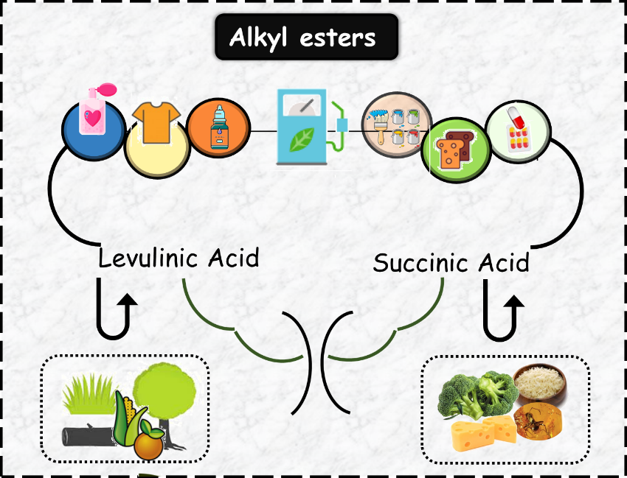
Scheme 1. C4 and C5 bio platform molecules and their applications

Material and Methods:
All materials used were of A.R. (analytical) grade. Levulinic acid, Succinic acid, n-butanol, 12-tungstophosphoric acid, Dichloromethane, Methanol were purchased from Merck. Zeolite NaY was acquired commercially from Reliance Industries Limited, Vadodara, Gujarat. The catalyst was synthesized in two steps, i) Conversion of zeolite NaY to HY by ion exchange method [2] ii) PW₁₂ was anchored to ZHY by incipient wet impregnation method. The synthesized materials were characterized by acidity measurements, FTIR, BET, EDX, TGA, ³¹P NMR, XRD and HRTEM. Further, PW₁₂/ZHY was used for the synthesis of fuel additives which was carried out in a simple batch reactor. Consequently, the effect of various reaction parameters such as mole ratio, catalyst amount, time, and temperature were studied to optimize the conditions for maximum conversion.

September 14-16, 2023, Institute of Chemical Technology, Mumbai

Significant Results and Discussion
BET analysis shows the successful anchoring of PW₁₂ into the pores of ZHY. The FTIR spectra indicates the intact structure of Keggin ion in the catalyst while, TGA shows the stability of the catalyst. The XRD and HRTEM reveals the uniform dispersion of PW₁₂ inside the pores of ZHY. For instance, HRTEM images of ZHY and PW₁₂/ZHY are shown in Figure 1.
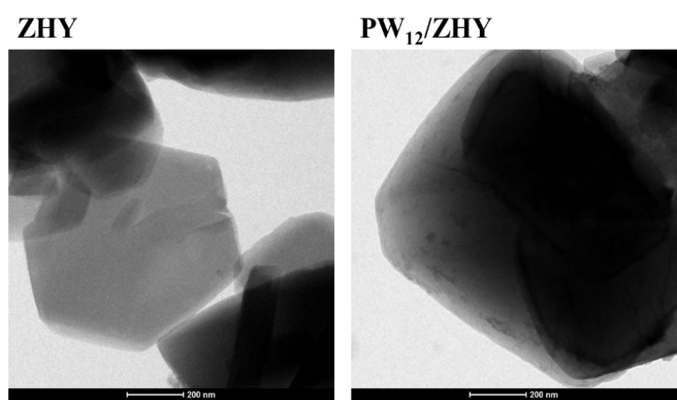
Figure 1. HRTEM images of support and catalyst
The catalytic activity of PW₁₂/ZHY towards esterification of levulinic acid as well as succinic acid with n-butanol was evaluated [2,3]. The superiority of the present work lies in getting very high conversion and selectivity for both the biofuel additives n-butyl levulinate and dibutyl succinate under mild conditions.
Table 1. Conversion and Selectivity
Esterification of bio platform molecules
Bio platform molecules | % Conversion | %Selectivity
Bio platform molecules | % Conversion | n- butyl levulinate | Dibutyl succinate
Levulinic acid | 88 | 99 | NA
Succinic acid | 92 | NA | 60

Conclusions:
A novel sustainable heterogeneous catalyst comprising 12-tungstophosphoric acid and zeolite HY demonstrating excellent catalytical performance in a solvent-free esterification reaction. Moreover, the removal of the catalyst consists of a single filtration and the catalyst can be reused after a simple work-up.
References

[1] KC Badgujar, BM Bhanage, Fuel Process Technol, 2015, 138,139–146.
[2] A. Patel, M. Joshi, S. Sharma, Biomass Conv and Bioref., 2022.
[3] A. Patel, M. Joshi, Energy fuels, 2023, 37, 13, 9247-9256.

