September 14-16, 2023, Institute of Chemical Technology, Mumbai
Unravelling the Synergistic Participation of Ni-Sn in Nanostructured NiO/SnO₂ for the Catalytic Transfer Hydrogenolysis of Lignin Model Compounds
Atul Kumar¹, Ashish Kumar Kar¹, Rajaram Bal² Rajendra Srivastava¹

¹Catalysis Research Laboratory, Department of Chemistry, Indian Institute of Technology Ropar, Rupnagar-140001, India.
²Nanocatalysis Area Conversion and Catalysis Division, CSIR-Indian Institute of Petroleum, Dehradun-248005, India.
E-mail addresses: atul.20cyz0002@iitrpr.ac.in, ashish.kar@iitrpr.ac.in, raja@iip.res.in, rajendra@iitrpr.ac.in

Introduction:
Lignocellulosic biomass, a renewable source with abundant availability, holds the scientific promise to replace fossil fuels in producing aromatic compounds and liquid fuels, thereby addressing environmental pollution, meeting energy demands, and offering a sustainable alternative to the conventional petroleum industry with reduced nitrogen and sulfur emissions and no net carbon dioxide output. [1]. Various techniques, such as pyrolysis, gasification, acid-catalyzed depolymerization, oxidation, hydrogenation, and hydrogenolysis, are widely used for lignin valorization. Catalytic transfer hydrogenation and catalytic transfer hydrogenolysis are particularly gaining attention, with the former reducing unsaturated double/triple bonds of C-X (where X = C and O) using hydrogen donor molecules, and the latter selectively cleaving saturated C-X bonds with suitable hydrogen donor molecules. [2] CTH shows promise for excellent substrate conversion and product selectivity under mild conditions, but researchers face challenges in maintaining aromatic selectivity, understanding mechanistic pathways, and employing affordable, a careful catalyst design and synthesis to prevent undesired hydrogenation of aromatic compounds. [3] This study aims to develop a simple non-noble metal catalyst for highly selective conversion of benzyl phenyl ether (BPE), 2-(benzyloxy)phenol (representing α-O-4 ether bond in lignin polymeric structure) and 2-phenoxy-1-phenylethan-1-ol (representing the β-O-4 ether bond in lignin polymeric structure) to aromatic products via sustainable catalytic transfer hydrogenolysis (CTH) using a nanostructured NiO(10%)/SnO₂ catalyst and isopropanol as the hydrogen source. The optimized NiO loading on SnO₂ plays a crucial role, achieving impressive BPE conversion (up to 95%) with exclusive aromatic selectivity (100%) at 250 °C for 4 hours. A simple and cost-effective nanostructured catalyst design, convenient and eco-friendly catalytic process for producing aromatic platform chemicals from discarded or low-cost abundantly available lignin is the strength of this work that will attract and motivate scientists and industrialists.

Material and Methods:
Figure 1 shows the stepwise synthesis of nanostructured NiO(x%)/SnO₂. SnO₂ was precipitated by mixing SnCl₄.5H₂O (2 g) solution A with sodium hydroxide (800 mg) and sodium carbonate (300 mg) solution B. After filtration, washing, and drying at 80 °C, SnO₂ was obtained by calcination at 600 °C. NiO(x%)/SnO₂ (where x = 5, 10, 15) was prepared by dispersing 500 mg of SnO₂ in 40 mL of ethanol, adding nickel nitrate hexahydrate, sonicating, and stirring for 3 hours. The material was then evaporated and calcined at 600 °C. The catalytic reaction (CTH) occurred in a batch reactor with BPE and catalyst in isopropyl alcohol at 10 bar and 250 °C for 4 hours with stirring. After cooling, the catalyst was separated by centrifugation. Product quantification and confirmation were performed using a gas chromatograph (GC) with a capillary column and flame ionization detector (FID), as well as GC-MS. The spent catalyst was recovered, washed, dried, and regenerated by calcination at 600 °C for 4 hours in a muffle furnace.
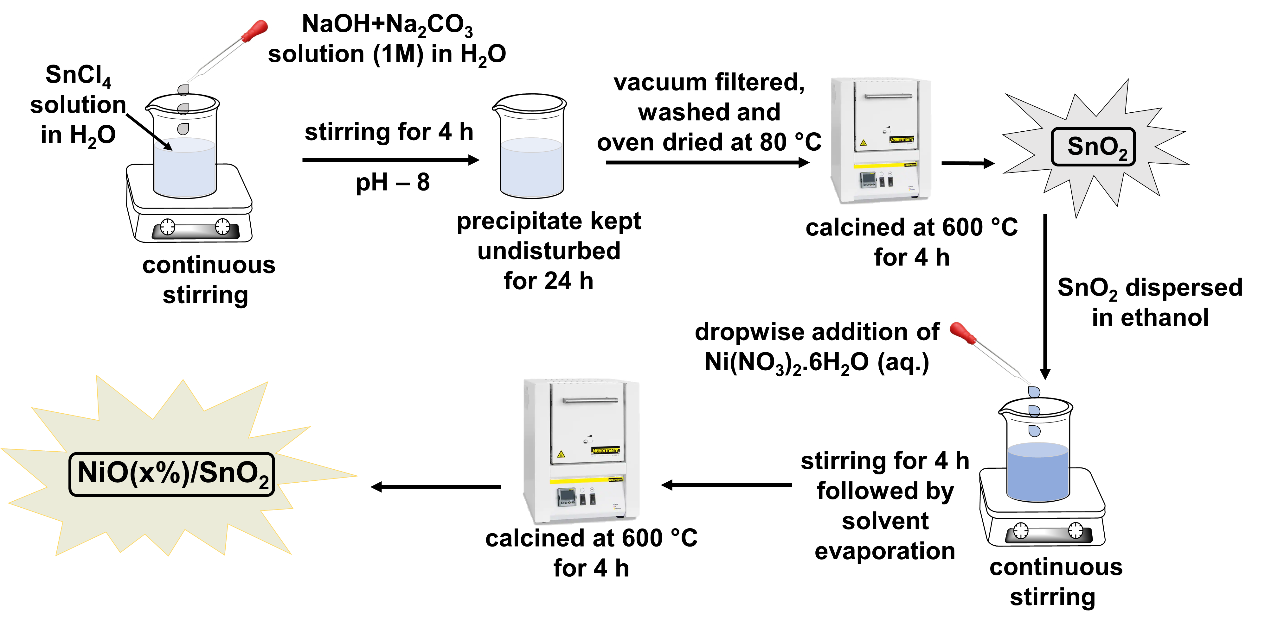
Figure 1: The preparation of SnO₂ and NiO(x%)/SnO₂ catalyst.

Significant Results and Discussion

3.1 Structure of the prepared catalyst
Nanostructured NiO/SnO₂ composite formation was confirmed through various characterization techniques. Powder X-ray diffraction (PXRD) patterns of the synthesized materials (SnO₂, NiO, NiO(5%)/SnO₂, NiO(10%)/SnO₂, and NiO(15%)/SnO₂) are shown in Figure 2 A-a. The diffraction peaks of pristine SnO₂ matched with the rutile phase (JCPDS No. 21-1250) at 2θ angles of 26.7°, 33.97°, 38°, 51.8°, 54.8°, and 66.1° (corresponding to planes (110), (101), (200), (211), (220), and (301), respectively), with lattice constants a = 4.738 Å and c = 3.188 Å. Pristine NiO exhibited diffraction peaks at 2θ angles of 37.5°, 43.5°, and 62.9° (corresponding to planes (111), (200), and (220) of cubic NiO, JCPDS No. 47-1049). The PXRD patterns of NiO/SnO₂ composites indicated successful NiO support on SnO₂, and the NiO peak intensity increased with higher NiO content in the composites (Figure 2 A-a). Figure 2 A-b shows the comparative N₂-sorption isotherms of nanostructured NiO/SnO₂ composites. All these samples possess a similar characteristic of a type IV isotherm (Figure 2A-b).
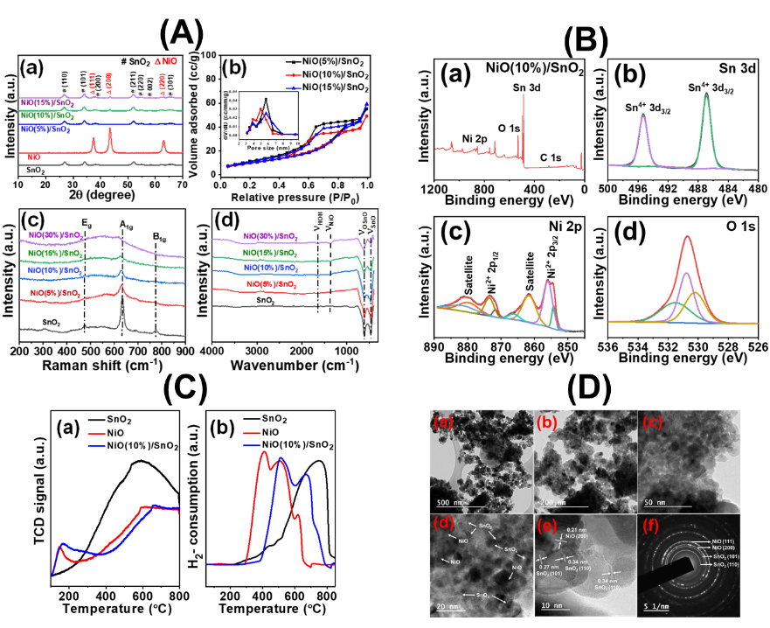
Figure 2. (A) [(a) PXRD patterns, (b) N₂-isotherms and pore-size distributions, (c) Raman-scattering spectra, and (d) FT-IR spectra] (B) XPS surface survey (C) NH₃-TPD and H₂-TPR ananlysis, (D) TEM, of the synthesized materials.
Raman spectroscopy (Figure 2 A-c) was used to examine crystal structure, defects, and vibrational modes in the composites. After loading NiO onto SnO₂, a noticeable shift in the Raman peak associated with A1g was observed. This shift corresponds to the contribution of transverse optical (TO) phonon modes of NiO at 505 cm-1. Increasing NiO loading on SnO₂ caused the band to shift to lower frequency, becoming broader and less intense, indicating lattice distortion, oxygen deficiency, and disruption in lattice space symmetry. FT-IR study also reflected defect creation, as peak intensity decreased and broadening occurred with higher NiO loading on SnO₂ (Figure 2 A-d). XPS surface survey showed the presence of Sn, Ni, and O in nanostructured NiO(10%)/SnO₂. O 1s peaks at BE of 530.1 eV, 530.8 eV, and 531.0 eV indicated lattice oxygen, oxygen adjacent to oxygen vacancy, and chemisorbed oxygen species, confirming oxygen vacancies in NiO(10%)/SnO₂ (Figure 2 B). NH₃-TPD and H₂-TPR profiles suggested surface coverage of SnO₂ by NiO, with interactions between their reduced states (Figure 2 C). TEM and SAED confirmed successful formation of nanostructured NiO(10%)/SnO₂ without altering SnO₂'s bulk structural morphology (Figure 2 D).
3.2 Activity towards the CTH of the lignin Model compounds
The activity of SnO₂ and nanostructured NiO(x%)/SnO₂ (x = 5, 10, 15) catalysts was studied in the CTH of BPE with isopropanol as the hydrogen source. SnO₂ showed low conversion (17%) with high selectivity for aromatic products. NiO improved conversion but decreased aromatic selectivity, while NiO(x%)/SnO₂ achieved high conversion with excellent aromatic selectivity. Increasing NiO loading to 10 wt % improved conversion to 95%, but further increase to 15% showed no significant improvement. Higher NiO-loaded composites (20% to 50%) were tested, with NiO(15%)/SnO₂ showing the best balance of conversion and selectivity. Model reactions using phenol and toluene confirmed the role of NiO in ring-reduction reactions (Table 1).
Table 1. Catalytic transfer hydrogenolysis of BPE over synthesized catalysts.
Entry | Catalyst | Substrate | ªConversion (%) | Aromatic Selectivity (%)
^{b}1 | None | Benzyl phenyl ether | 0 | -
^{b}2 | SnO₂ | Benzyl phenyl ether | 17 | 100
^{c}3 | NiO | Benzyl phenyl ether | ∼100 | 25.1
^{b}4 | NiO(5%)/SnO₂ | Benzyl phenyl ether | 90 | 100
^{b}5 | NiO(10%)/SnO₂ | Benzyl phenyl ether | 95 | 100
^{b}6 | NiO(15%)/SnO₂ | Benzyl phenyl ether | 96 | 100
^{b}7 | SnO₂-R | Benzyl phenyl ether | 14 | 100
^{b}8 | NiO(10%)/SnO₂-spent | Benzyl phenyl ether | 24 | 100
^{b}9 | NiO(10%)/SnO₂- R | Benzyl phenyl ether | 20 | 100
^{b}10 | NiO(10%)/SnO₂- reg. | Benzyl phenyl ether | 97 | 100
^{d}11 | NiO(10%)/SnO₂ | 2-(benzyloxy)phenol | ~ 99 | 100
^{e}12 | NiO(10%)/SnO₂ | 2-phenoxy-1-phenylethan-1-ol | ~ 99 | 100
Reaction conditions: BPE (0.5 mmol), isopropyl alcohol (10 mL), catalyst (60 mg), temperature (250 °C), time (4 h), and N₂ (10 bar). ªSubstrate conversion is presented in integer which is average of three analysis. ^{b}Hydrogenolysis products of BPE (phenol and toluene) were obtained. ^{c}Reduced product of phenol and toluene were obtained. ^{d}Hydrogenolysis products of 2-(benzyloxy)phenol (catechol, 2-isopropoxyphenol and toluene were obtained. ^{e}Hydrogenolysis products of 2-phenoxy-1-phenylethan-1-ol (phenol, styrene, acetophenone, 1-phenylethan-1-ol, ethylbenzene) were obtained.

3.3 Catalyst recyclability and heterogeneity
NiO(10%)/SnO₂ catalyst was recyclable in BPE CTH. After the reaction, the catalyst turned black due to metallic Sn, Sn-Ni alloy, and Ni NPs formation, confirmed by XRD and XPS. Regenerated at 600 °C (NiO(10%)/SnO₂-reg), it regained original appearance and activity. Regenerated catalysts, maintained activity over multiple runs. Hot filtration test confirmed catalyst heterogeneity, as BPE conversion didn't increase without the catalyst (Figure 3 A).
3.4 Plausible mechanism for CTH of BPE
The mechanism for CTH of BPE over NiO(10%)/SnO₂ involves synergistic participation of SnO₂ and NiO, providing appropriate acid-base surfaces and oxygen vacancies for BPE adsorption and isopropanol activation. Theoretical studies suggest benzyl and phenoxy radicals as feasible hydrogenolysis intermediates. Oxygen vacancies on NiO(x%)/SnO₂ surface facilitate BPE adsorption, while isopropanol adsorption occurs on Lewis acidic (Ni^{δ+}, Sn^{δ+}) and basic (O²⁻) centers. Hydrogen transfer from isopropanol to BPE weakens the C-O bond and produces phenoxy radicals, which convert to toluene and phenol (Figure 3 B).
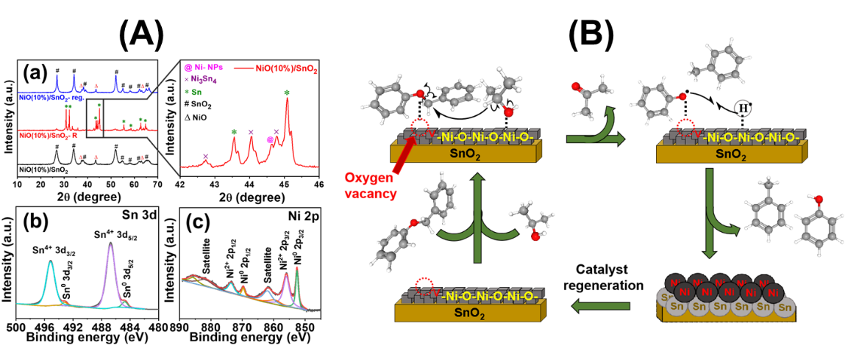
Figure 3. (A) PXRD, and XPS of the reduced and regenerated catalyst (B) Plausible mechanism for the CTH of BPE.

Conclusions:
In conclusion, nanostructured NiO(10%)/SnO₂ showed 100% selectivity in converting BPE into aromatic compounds (phenol and toluene) via CTH using isopropanol as a hydrogen source, without using precious metals. Optimum NiO loading and reaction conditions were identified for the best activity. Precise NiO loading on SnO2 was crucial for complete BPE conversion and 100% aromatic selectivity. NiO(10%)/SnO₂ underwent reduction during the reaction but could be easily regenerated for the next catalytic cycle. Surface oxygen vacancies and acidic/basic sites played key roles in BPE adsorption and activation. Mechanistic investigations and catalyst characterizations supported the understanding of the true catalytic center in NiO(10%)/SnO₂. This study's findings offer promising insights for designing various cost effective, easy to prepare, Sn-Ni derived catalysts in the CTH of lignin polymer into value added aromatic scaffolds selectively.

References

[1] M. Zaheer, R. Kempe, ACS Catal. 5 (2015) 1675–1684.
[2] A. Shivhare, D. Jampaiah, S.K. Bhargava, A.F. Lee, R. Srivastava, K. Wilson, ACS Sustain. Chem. Eng. 9 (2021) 3379–3407.
[3] J. Ji, H. Guo, C. Li, Z. Qi, B. Zhang, T. Dai, M. Jiang, C. Ren, A. Wang, T. Zhang, ChemCatChem 10 (2018) 415–421.

