Effects of Capping Agents in the Synthesis of Cerium Oxide Nanoparticles by Co – Precipitation Method
¹Sureshkumar. K*, ¹Ashif Mohamed A, ¹Vinisha. M, ²Sakthivel.M, ²Kannan.P.N, ²Sivasankari.C* & ¹Sakthivel.P*
¹Department of Nanoscience and Technology, Bharathiar University, Coimbatore-641046
² Department of Chemistry, Government College of Technology, Coimbatore-641013
E-mail addresses: ksuresh022@gmail.com*, sankari@gct.ac.in*, polysathi@gmail.com*

Introduction:

The frequent use of capping agents in colloidal dispersions, capping agents are frequently used to control the development, agglomeration, and physico-chemical properties of nanoparticles [1]. The capping agent is an amphiphilic molecule with a non-polar hydrocarbon tail and a polar head group. Capping agents confer functionality and improve compatibility with another phase because of their amphiphilic character. Various capping agents, such as surfactants, amino acids, polysaccharides and polymers have been utilized in the creation of nanoparticles. Among these capping agent, polymers may improve the optical, electrical, and physical properties of pure CeO₂ NPs. The polymers must have low toxicity, great water solubility, biocompatible lubricity, and thermal stability in order to serve as efficient binders. Polyethylene glycol (PEG), polyvinyl pyrrolidone (PVP), and polyvinyl alcohol are the most typical polymers used as binders during the synthesis of metal oxide nanoparticles [2].Additionally, it is well known that CeO₂ is virtually insoluble in water and aggregates right away during synthesis due to the strong polarity of the water, which causes deposition. As a result, during the creation of CeO₂ NPs, a number of issues such as aggregation, re-precipitation, settling, or non-dissolution develop. Thus, the employment of polymers as capping agents is taken into consideration as a solution to these issues.

Material and Methods:

Synthesis of CeO₂ Nano materials

The CeO₂ nanoparticles synthesized via chemical co-precipitation method. The 4.34g of Ce (NO₃)₃.6H₂O is dissolved in 75 ml of distilled water and maintains continuous stirrer for 30 minutes. After 30 mins 2 mg of PVP (Polyvinyl pyrrolidone) is dissolved in 25Ml of distilled water, where it is mixed with solution containing Ce(NO₃)₃.6H₂O.And maintains continuous stirrer after than 2g of NaOH is dissolved in 50 ml of distilled water and then added to above solution containing PVP and Cerium nitrate. A yellow precipitate is formed and solution is kept on stirring at room temperature for 6 hours. Then obtained solid precipitate was washed several times with 8:2 ratio of acetone and di water using centrifuge method, dried at 60 ^{ₒ}C and powdered the CeO₂ nanoparticles. Following above the process the ceria was prepared using other capping agents such as PVA, PEG.
  - Oxidation of cyclohexane:

The oxidation of cyclohexane was carried out in a 50 ml round bottom flask fitted with a reflux method. In a typical test, 50mg catalyst was dispersed into 15 ml of acetonitrile and 1ml of cyclohexane at 45^{ₒ}C, then ml of H₂O₂ was slowly injected to the mixture. After each reaction, the catalyst was separated with the liquid by centrifugation. The structure of products and by products were identified using gas chromatography mass spectroscopy (GCMS) with an HP-5 capillary column (30m x 0.28mm, 0.25 um film thickness) by comparing retention times and fragmentation patterns with authentic samples. Reusability test of catalyst was conducted as follows: the catalyst was collected by centrifugation and washing with ethanol three times to remove the products, followed by calcination at 300^{ₒ}C in muffle furnace for 2 hours. After this treatment, the obtained catalyst was tested for the second time reaction.

Significant Results and Discussion

XRD Analysis:
The phase purity and crystal structure of the synthesized nano particle were examined by XRD pattern. The XRD patterns of CeO₂ (WC), CeO₂ (PVP), CeO₂ (PEG) and CeO₂ (PVA) nanoparticle were shown in Fig.3.1. The diffraction peaks found at 28.56°, 33.08°, 47.47°, 56.36° and they correspond to (111), (200), (220), (311) lattice planes, respectively. The obtained lattice parameters for ceria nanoparticles are observed to be in good agreement with the data reported in the Literature (JCPDS43-1002).
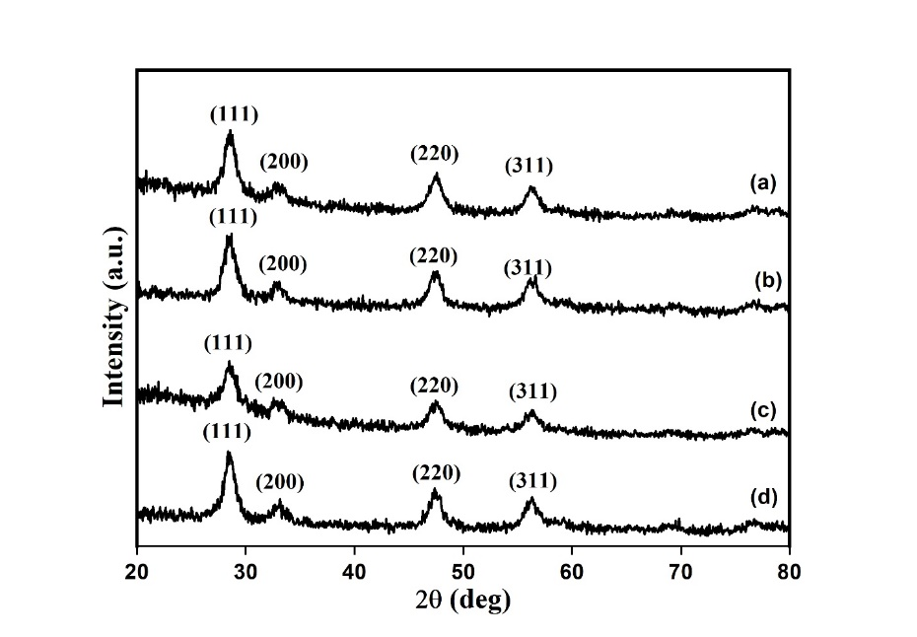
Fig. 3.1 XRD images of (a) CeO₂ (WC), (b) CeO₂ (PVP) (c) CeO₂ (PEG) and (d) CeO₂ (PVA) nanoparticle
  - Oxidation of Cyclohexane
The oxidation of cyclohexane was carried out in the room temperature in the presence of CeO₂ (WC), CeO₂ (PVP), CeO₂ (PEG) and CeO₂ (PVA) nano catalyst. The CeO₂ nano catalyst for selective oxidation of cyclohexane (CH) to cyclohexanone (CHone) using H₂O₂ as oxidant, Acetonitrile as solvent. All catalytic experiments are carried out at room temperature. The conversions under different catalysts were calculated from GCMS and these are presented in Table 3.1. It is observed that CeO₂ (PVP) nano catalyst shows high cyclohexane conversion (45%) together with 78% selectivity for cyclohexanone. Blank reactions have been carried out without catalyst and they show almost no conversion, which implies that the oxidation reaction cannot proceed without the catalyst. The influence the capping agent in synthesis of CeO₂ nano particle correlated to conversion of cyclohexane and selectivity of the product towards cyclohexanone.
Table 3.1 Catalytic oxidation of cyclohexane (CH) to cyclohexanone (CHone) over different catalysts.
S.No | Catalyst | CH Conversion (%) | CHone Selectivity (%)
1 | - | 4.2 | -
2 | CeO₂ (WC) | 19 | 45
3 | CeO₂ (PVP) | 45 | 78
4 | CeO₂ (PEG) | 39 | 65
5 | CeO₂ (PVA) | 36 | 63

Reaction conditions: Catalyst 60mg: 5mmol of cyclohexane, Solvent: 15 ml Acetonitrile, Oxidant: 20 mmol H₂O_{2 ,}Temperature : Room temperature, Time: 8 h

- Summary and Conclusion
The synthesis of CeO₂ (WC), CeO₂ (PVP), CeO₂ (PEG) and CeO₂ (PVA) nano particle was successfully synthesized and then analyzed by XRD, UV, TGA and FESEM. The synthesized nano particle was evaluated by the selective oxidation of cyclohexane using H₂O₂ as oxidant at room temperatures. The synthesized CeO₂ (PVP) nano particle showed high conversion and maximum selectivity. Hence, the influence the capping agent in synthesis of CeO₂ nano particle correlated to conversion of cyclohexane and selectivity of the product towards cyclohexanone.
- Reference
- Z.Niu, Y.Li, Chem Mater. 26, 2014, 72–83.
- J.Junaidi, K.Triyana, E.Suharyadi, H.Sabarman, L.Wu, J Nano Res. 49, 2017, 174–180.

